**Explaining and Ensuring Interoperability Working with Guardrails Editor Data Set**

* Interoperability with the pumps works by programming the order data from Cerner directly into the Alaris pumps by associating the pump when the nurse is charting administration. This screen shows where the nurse does this in the administration charting process. This nurse will click Program on this screen to start the pump association:

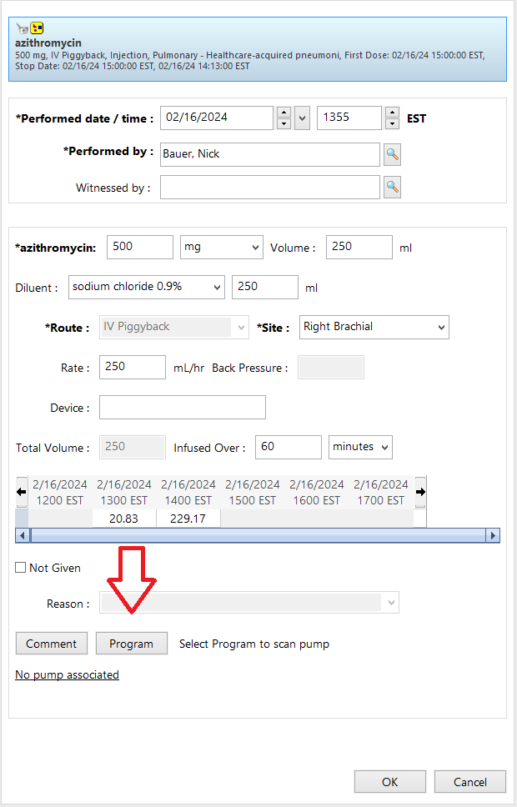

* After clicking that button, the nurse scans the barcode on the pump and all order information is automatically programmed.
* In order for the Guardrails Editor Data Set to match the drug with the same drug in Cerner, the correct “Alias” has to be put into the Data Set for both each drug and each concentration. The aliases are shown in the Master Drug List in Guardrails Editor:

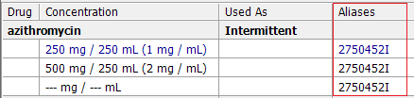

* The “Alias” in Guardrails Editor corresponds to the term Cerner uses called a “Catalog Code”. A Catalog Code is unique PER DRUG and not per product (i.e. an acetaminophen rectal suppository and acetaminophen IV both have the same catalog code).
* To get the Catalog Code for a drug in Cerner, get to a screen where you’re either inquiring or entering an order for that drug in Med Manager. Here shows an Inquire on azithromycin and where you click to get to the screen that shows a Catalog Code:

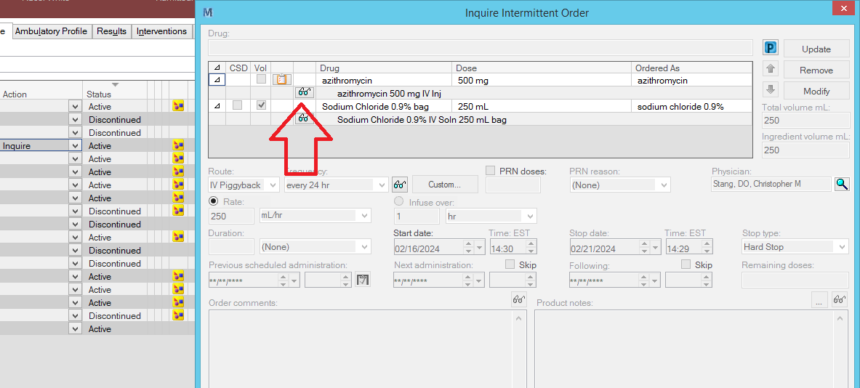

* This pops up a small window showing a lot of behind the scenes IDs that Cerner uses for that drug and product, but we are only interested in one for this:

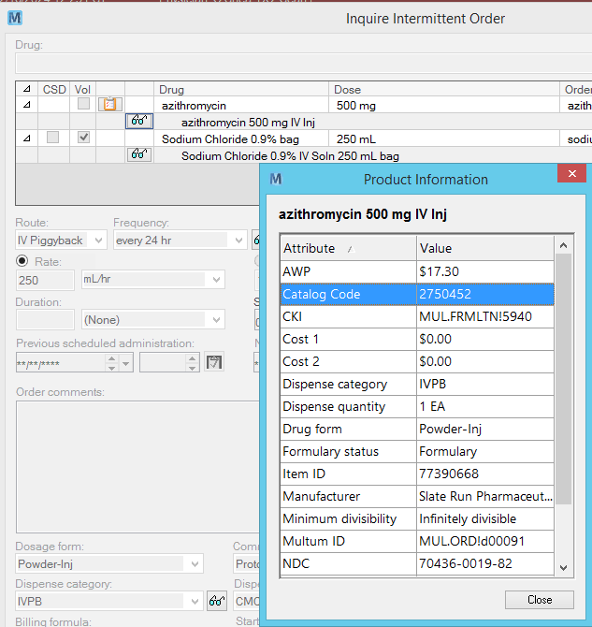

* The Catalog Code shown here matches the Alias in Guardrails Editor with one difference. The Alias in Guardrails Editor has a capital I on the end of it.
* Guardrails Editor has three different categories of Aliases: continuous, intermittent, and fluids.
* INTERMITTENT aliases like this only receive the drug strength, total volume, and rate from Cerner. In this order, these fields from Med Manager are programmed into the pump by using the capital I at the end of the alias:

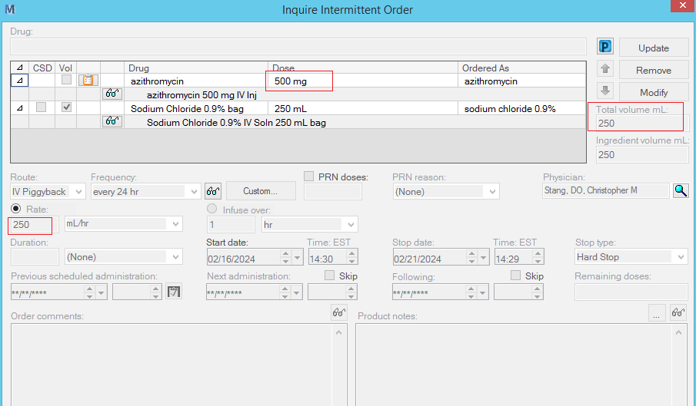

* This lets it match this specific drug and concentration in Guardrails Editor:

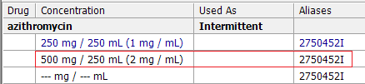

* The one thing to be careful of when entering concentrations into Guardrails Editor, is a drug that is a liquid that adds its own volume to the total volume, like this example:

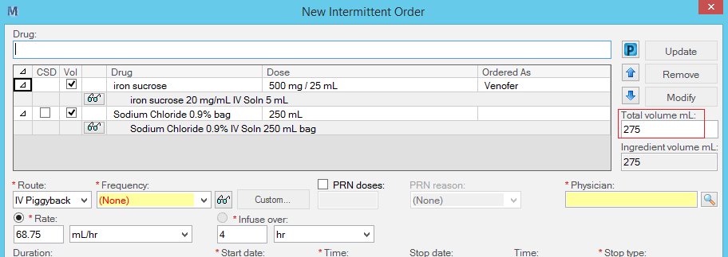

* The total volume sent to the pump must match an entry for a concentration in your Guardrails Editor Data Set (unless you have a units only concentration like --- mg / --- mL active, then it will always match). Here is how that concentration for iron sucrose looks in Guardrails Editor:

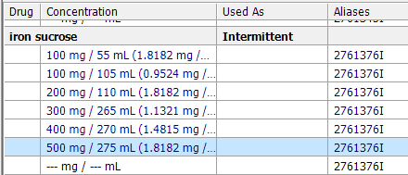

* CONTINUOUS aliases in Guardrails Editor receive a piece of information from Cerner that’s not in Med Manager, but in the nursing charting screen, the dosing units:

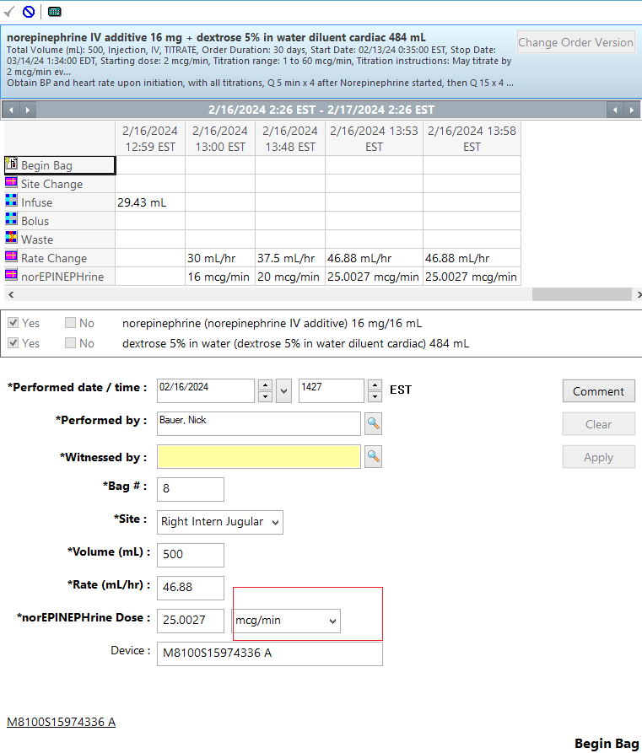

* In order for this to program the pump the pump, their documented units here need to match the units in Guardrails Editor, as shown here:

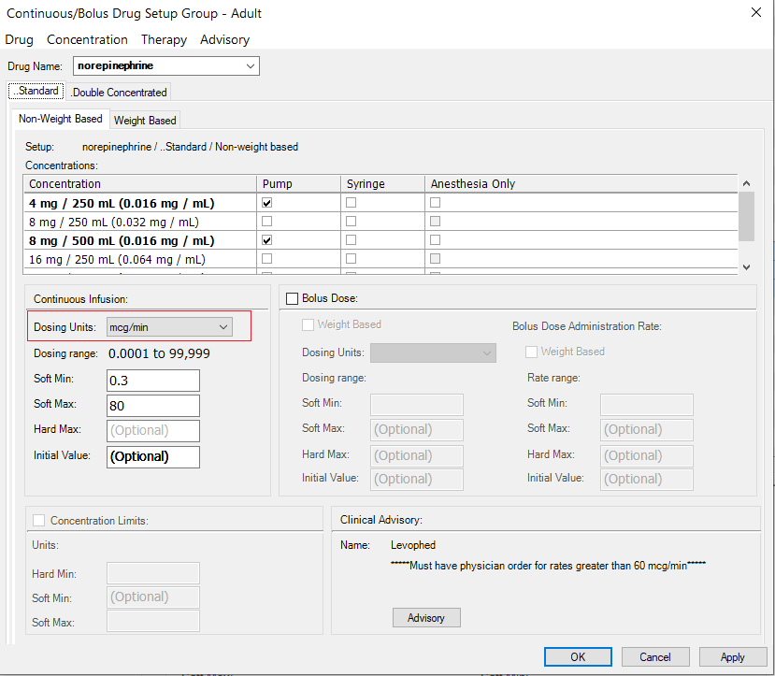

* The main difference between a CONTINUOUS alias in Guardrails Editor and a FLUID alias, is that a fluid only sends over the Rate from Cerner and nothing else.
* Generally, only actual (i.e. in real life) fluids, like normal saline or dextrose, but is also useful if you only want the pump to be programmed to an entry only by the rate where the dose/amount of the drug does not matter for the pump. An example would be a Bicarb Drip, where the main concern from the pump isn’t how many mg of sodium bicarbonate there is, but how fast the bag is being given:

